*Use the information in Chapter 4 (p. 58-65) to complete the following reading guide. The following Bozeman podcasts are also helpful:* [Abiogenesis](https://paul-andersen.squarespace.com/010-abiogenesis) and [The Molecules of Life](https://paul-andersen.squarespace.com/science-videos/2012/3/19/the-molecules-of-life.html).

**Concept 4.1: Organic chemistry is the study of carbon compounds**

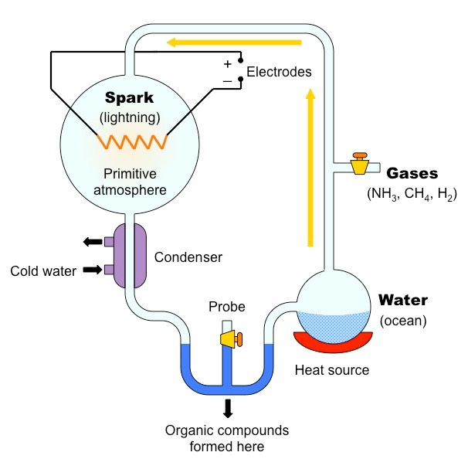

Use the diagram to explain the experimental design as well as the results of Stanley Miller’s experiment.

When Miller performed the experiment without electrical discharge, no organic compounds were found. What might explain this result?

**Concept 4.2: Carbon atoms can form diverse molecules by bonding to other atoms**

*Complete the following table in which you illustrate the ways carbon skeletons can vary.*

|  |  |  |
| --- | --- | --- |
| **Variation** | **Structure Example** | **Name of Compound** |
| Length |  |  |
| Branching |  |  |
| Double Bond Position |  |  |
| Presence of Rings |  |  |

Define the term “isomer”.

*Complete the following table in which you illustrate the different types of isomers.*

|  |  |  |
| --- | --- | --- |
| **Type of Isomer** | **Isomer 1** | **Isomer 2** |
| Structural |  |  |
| Cis-trans |  |  |
| Enantiomer |  |  |

**Concept 4.3: A few chemical groups are key to the functioning of biological molecules**

*Draw the structure of each functional group and list the properties of each.*

|  |  |  |
| --- | --- | --- |
| **Functional Group** | **Structure** | **Functional Properties** |
| Hydroxyl |  |  |
| Carbonyl |  |  |
| Carboxyl |  |  |
| Amino |  |  |
| Sulfhydryl |  |  |
| Phosphate |  |  |
| Methyl |  |  |